Axiom Requisition Copy Service
447 North Canal Road, Lansing, Michigan 48917
517.886.5099 – 877.886.5090 toll free – 517.886.4116 facsimile

Michael Lalikos, Esquire
Schneider & Lalikos
8 Essex Center Drive
Peabody, MA 01960

RE: Mulcahy v. Uppington
Middlesex County Superior Court Division Civil Action No.: 08-04051

Dear Attorney Lalikos:

Attached pursuant to Rule 30 and Rule 45 of the Massachusetts Rules of Civil Procedure, is a copy of the Keeper of Records Notice of Taking Deposition and Subpoena for the following locations and relating to the above-captioned matter:

Town of Wakefield (Employment Records)

In accordance with the requirements of the Health Insurance Portability and Accountability Act (“HIPAA”) Privacy Standards, please notify your client that these records are being sought. In addition, please notify your client that he/she and you have ten days from the date of this letter to raise objections to any subpoena for medical records in the court in which we have brought the proceeding. If, after ten days, I have received no notification from you that any objection has been raised, I will assume that there is no objection to this request for information, and will so notify the Keeper of Records for the above-named provider.

Thank you for your attention to this matter.

Very truly yours,
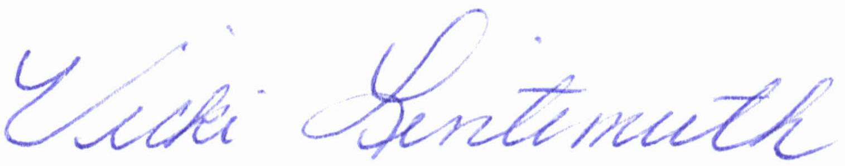

Vicki Lintemuth

Enclosure
Order No. 01-17101-007

